Part A

Develop software to perform a DFS starting at Chicago (always choose the edge with the smallest mileage). Identify the discovery edges and the back edges. What is the total distance travelled on the discovery edges? Use an Adjacency List structure. Output the Adjacency List.

Part B

Develop software to perform a BFS starting at Chicago (always choose the edge with the smallest mileage). Identify the discovery edges and the cross edges. What is the total distance travelled on the discovery edges? Use an Adjacency Matrix structure. Output the Adjacency Matrix.

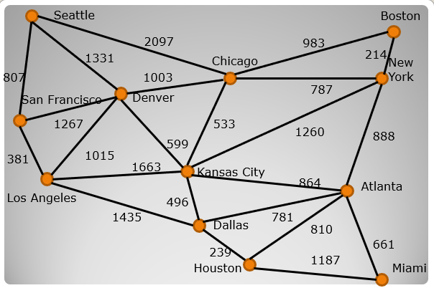

Work with one partner from your project 2 team.

Due November 13th.